2001 T-108 sn1752 Truck Mounted Rig
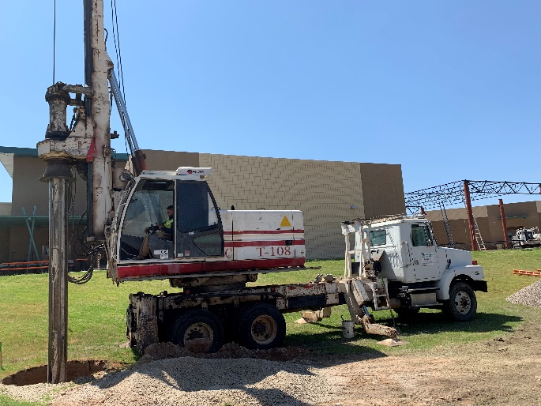
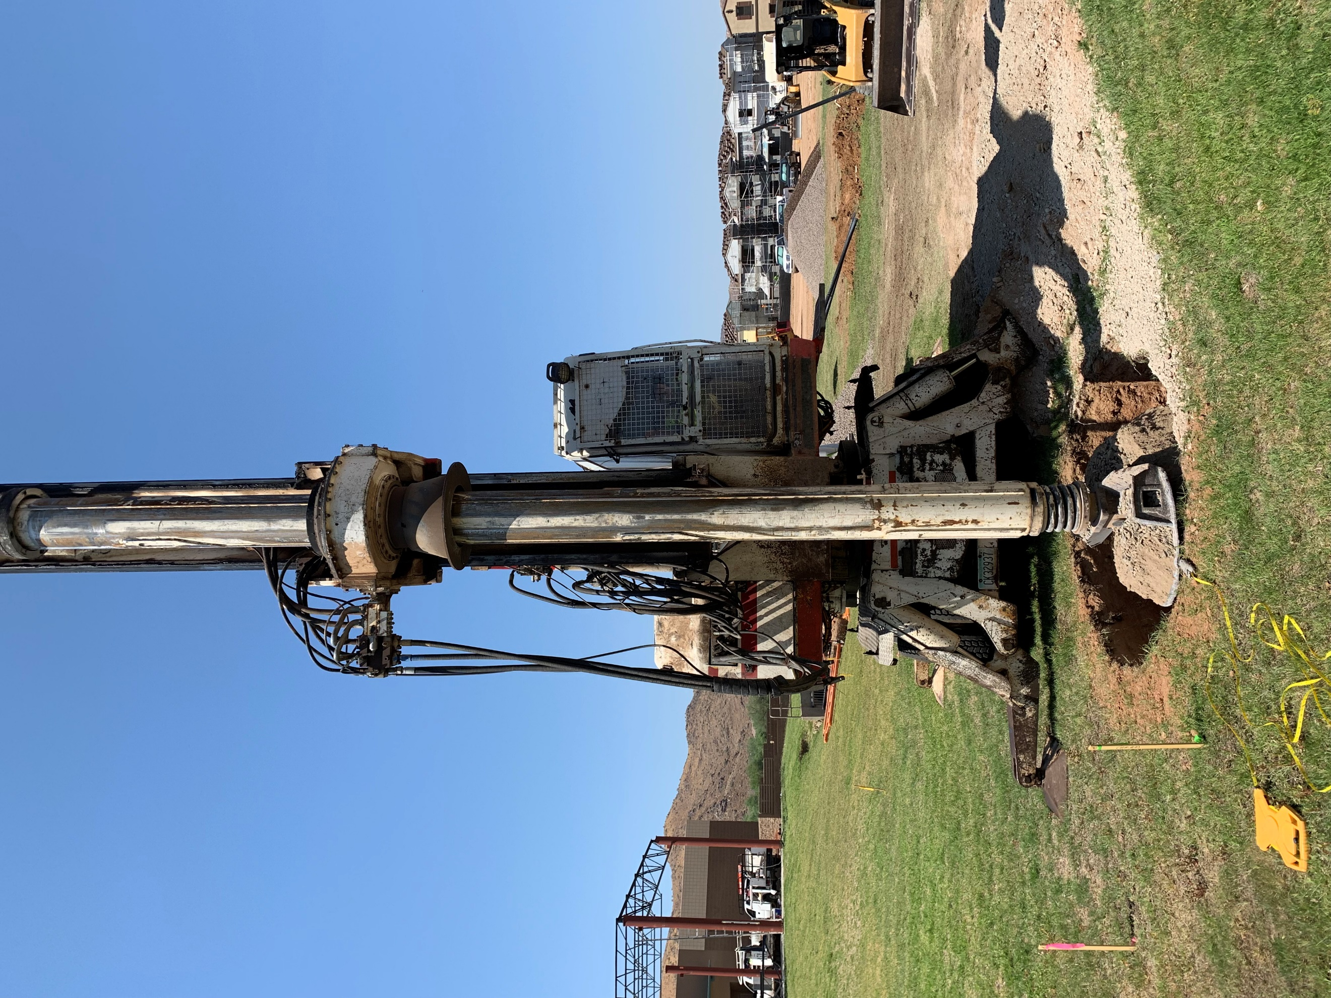

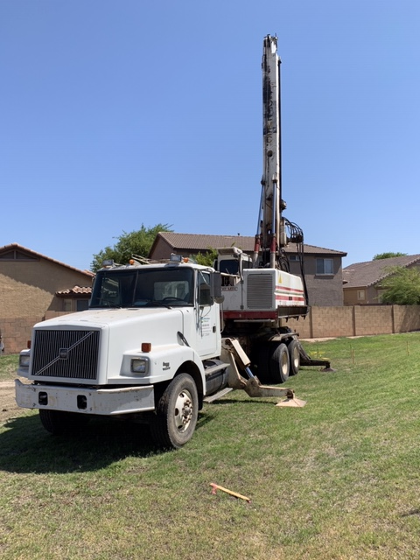

- Air conditioning in both chassis cab and drill rig cab
- Volvo chassis 92K Miles
- New engine in drill rig around 2015
- Tools available upon request
- $225,000.00

