2002 Soilmec T-108 sn1827
Mounted on a 95 Kenworth T800
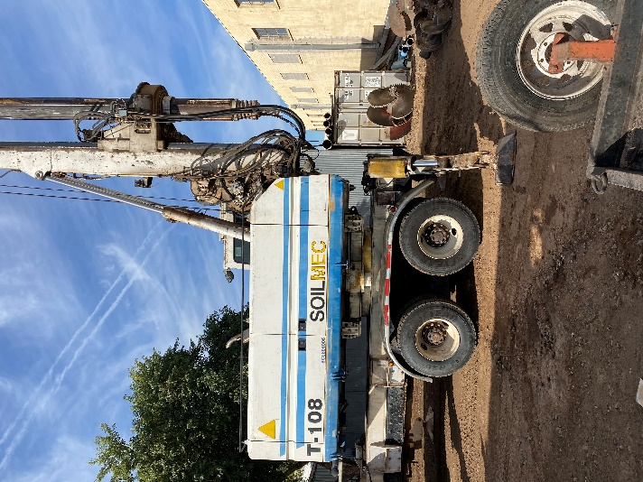
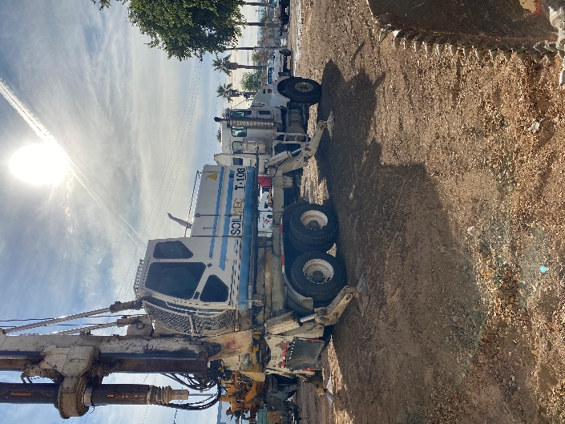
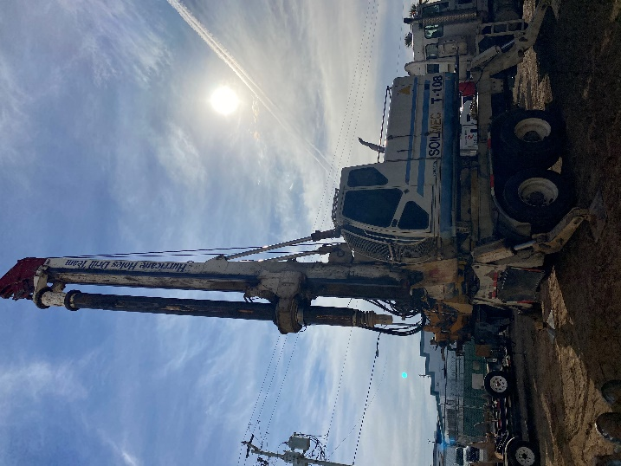

New Engine Approx. 100 Hours
Rotary Rebuilt / New Slew Ring
New Mast Lifting Cylinders
4 x 7 Locking Kelly Bar

SALE PRICE: $220,000.00
$100,000 of upgrades completed on machine

*Financing available

