2002 Soilmec T-108 sn1827
Mounted on a 95 Kenworth T800
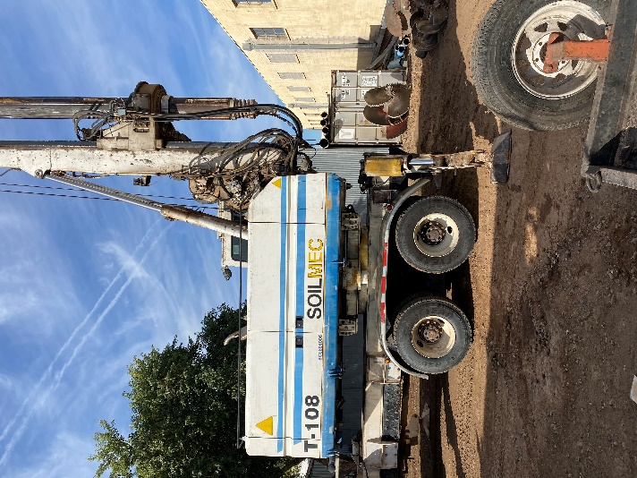
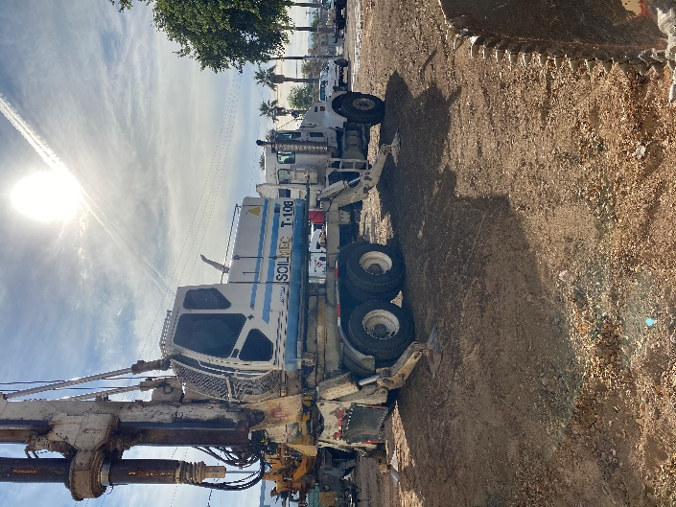
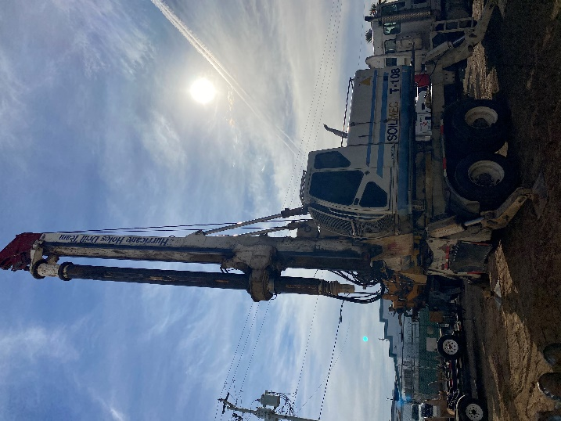

New Engine Approx. 100 Hours
4 x 7 Locking Kelly Bar

SALE PRICE: $235,000.00
or $3,917.67 for 60 Months

