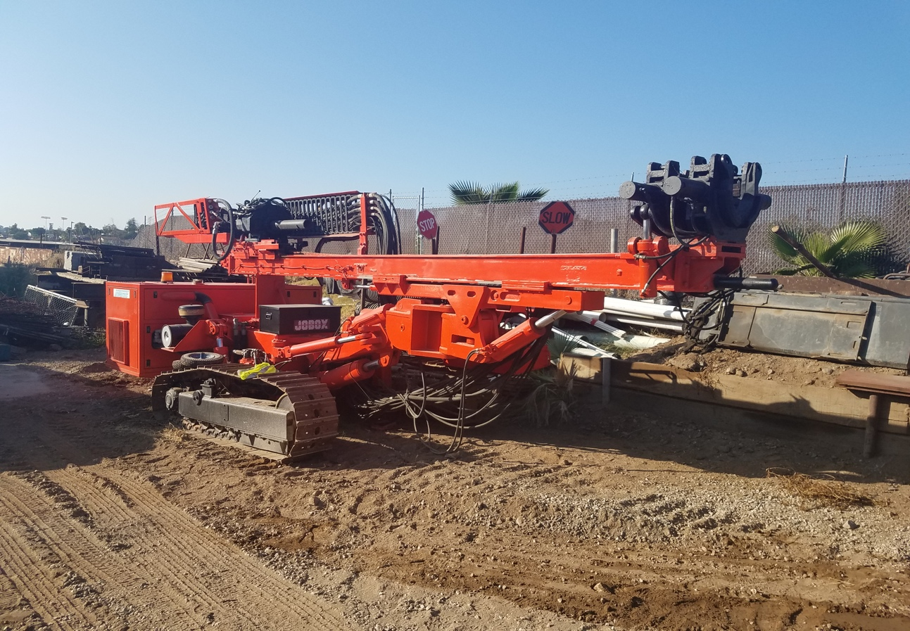
2002 INTEROC AN109B

3066 HRS
Clamp and Breaker 10” diameter
14 Foot stroke/travel
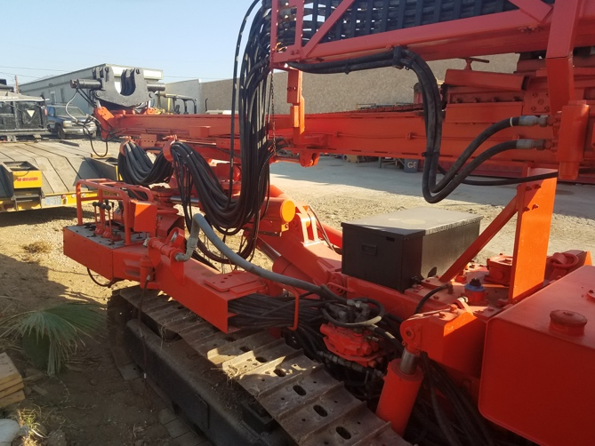
Rotary head Tornado 3 Speed 9600 lb torque
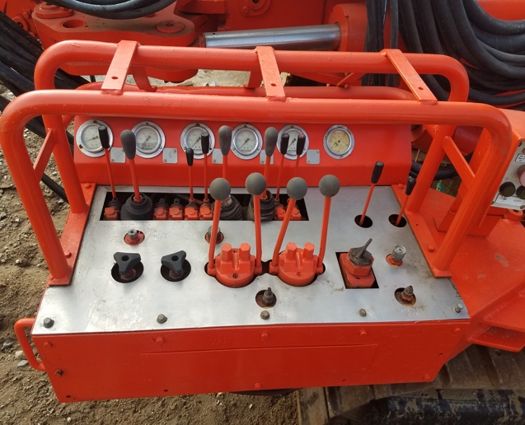

$50,000

