2004 R516
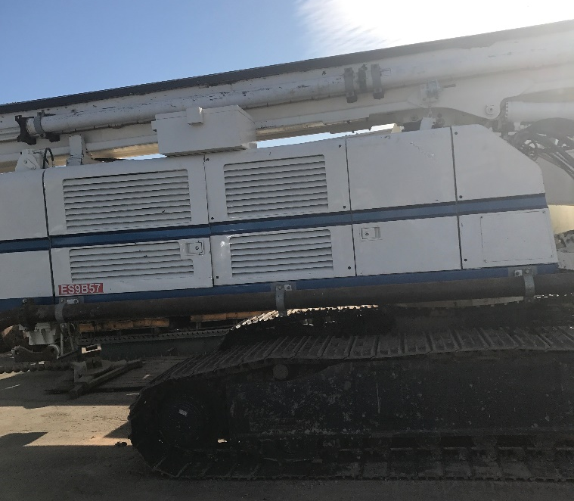

- New CAT C7 Engine Put in 2016
- New Engine Approx. Hours 1,000
- Total Hours on Rig 11,724
- 4x10.5 Kelly Bar
- $140,000
