2007 WATSON 1100TM

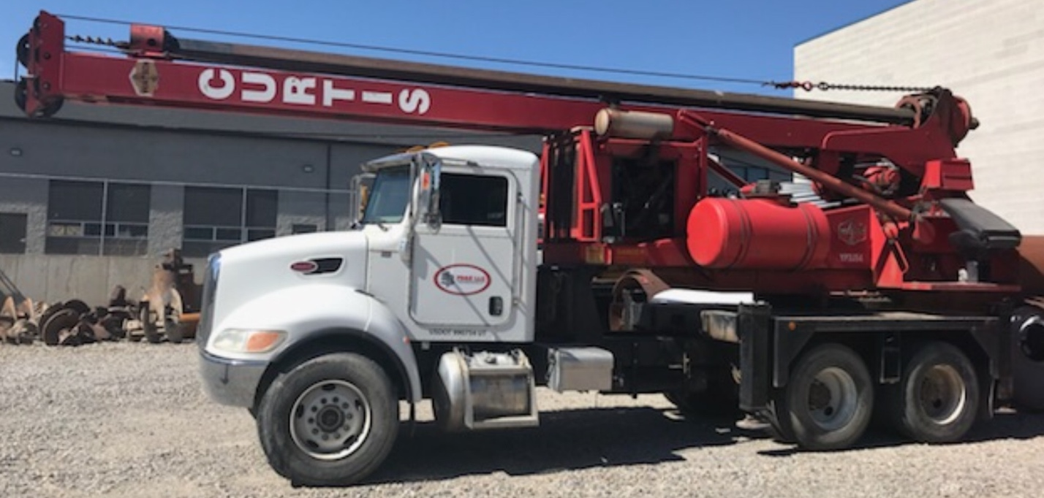

John Deere 4045T-140hp (Tier III)
45,000 ft-lbs Torque Rotary
50 foot drill depth
2-bar kelly (6" outer / 4.25" inner)
18,000 lb. Kelly Winch
21,700 lb. Crowd Force
46,000 lb. Transport Weight

$285,000

