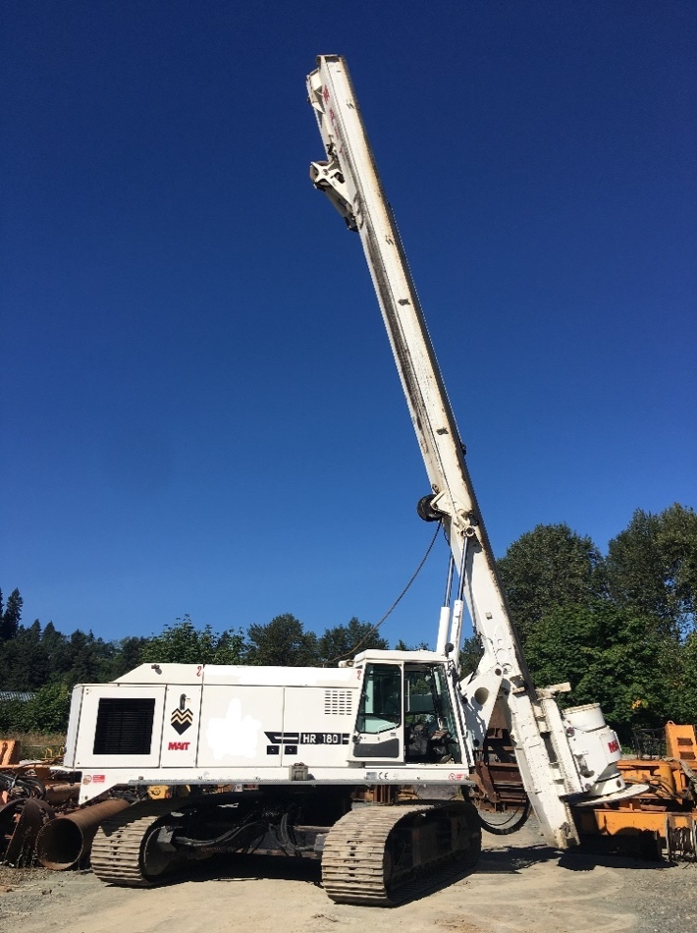
2010 MAIT HR180

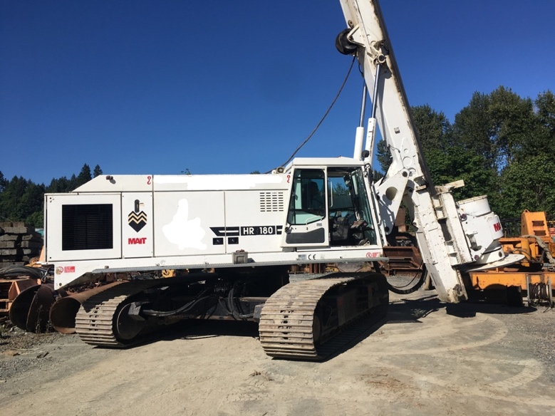

Caterpillar C9 242 KW Engine
Approx. Hours 6,000
Torque: 233 kNm
$250,000
Or $4660.75 for 60 months

*This quote/payment is for budgetary purposes only and is not an offer to finance. Taxes, registration, and related charges have not been included. Rate quoted is OAC and subject to change without notice

