2012 SR-30 SN 4151
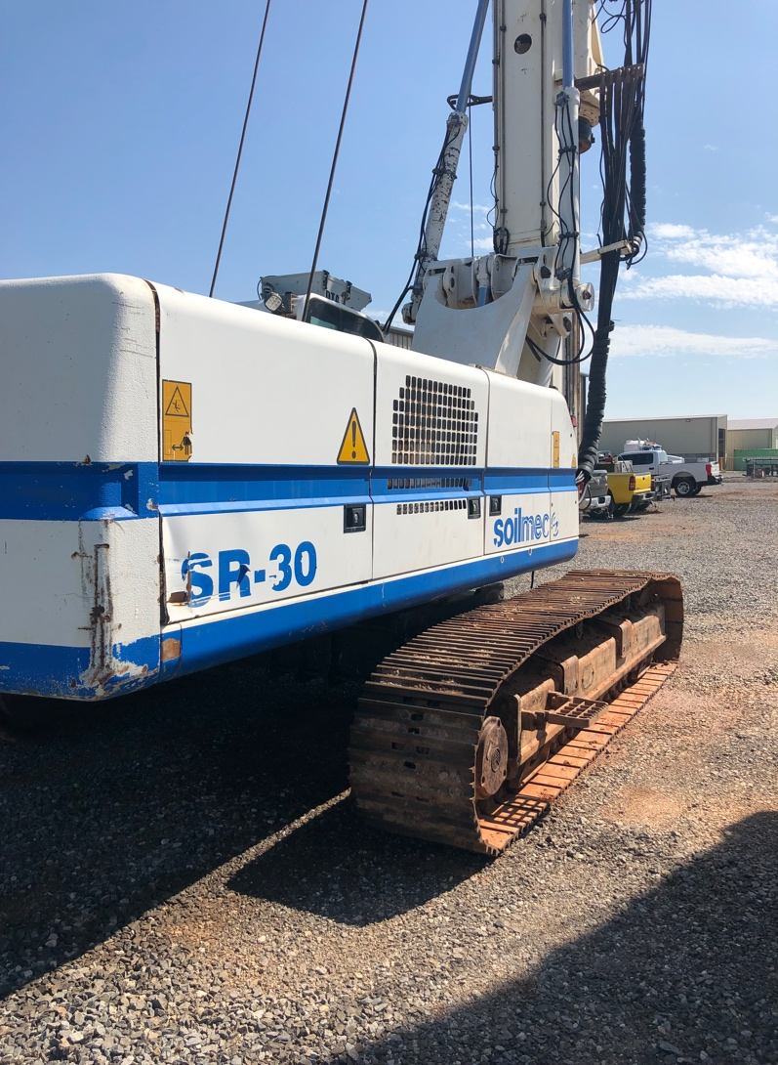
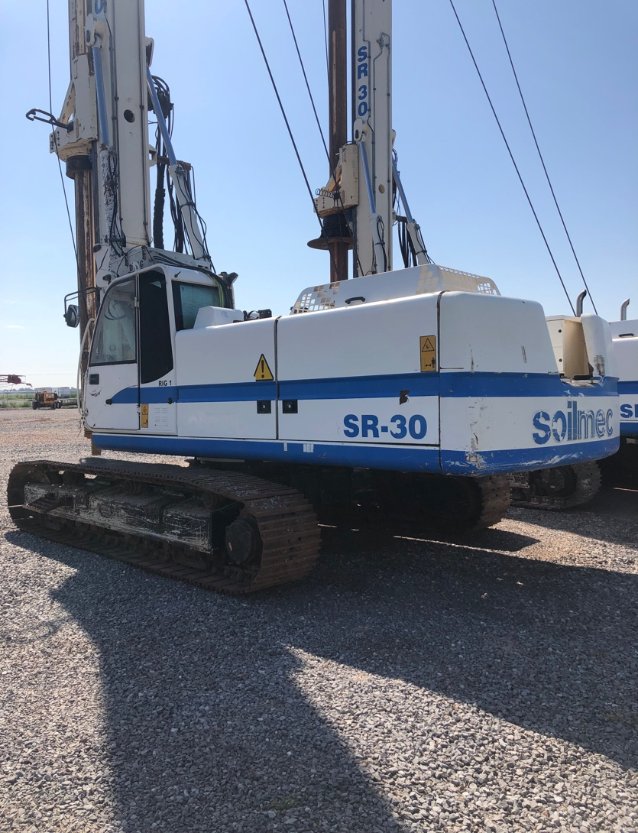

- 9869 Hours
- 4x12.5m Locking Kelly Bar
- $249,000

