Western Equipment Solutions
For Information, Please Call
Craig Berninger: 801.560.9170
craigb@westernequipmentsolutions.com

2014 Hutte HBR 502-2 Crawler Drill
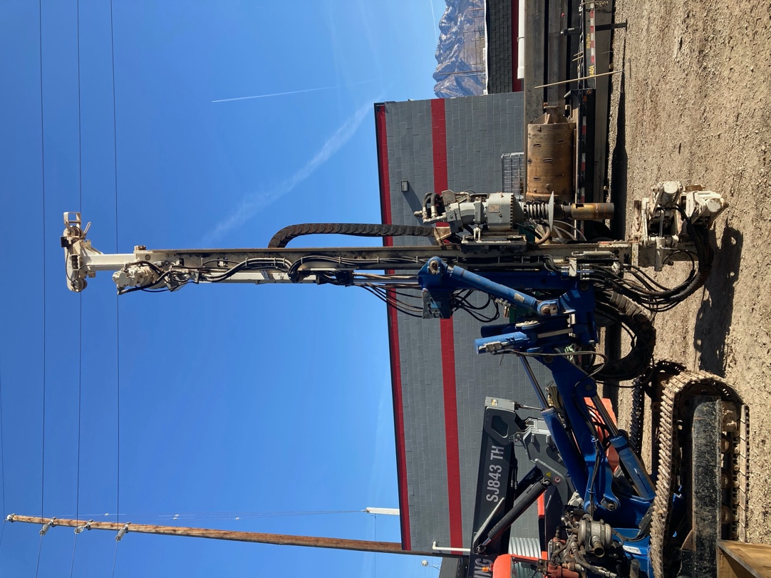

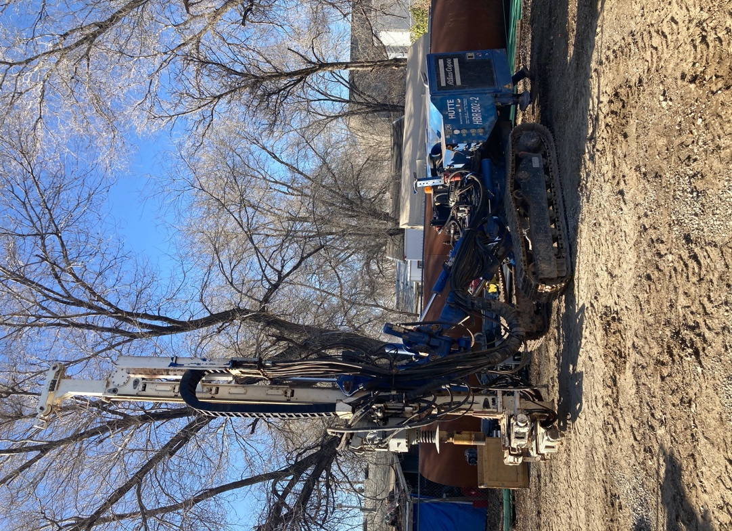

1755 Hours

T14 Rotary complete with tooling

6 each 152 mm X2 m casing with duplex adapter, 2 crown bits for 152 casing,

Duplex adapter for 8” permanent casing

SALE PRICE: $175,000.00
or $3001.90 for 60 Months

*This quote/payment is for budgetary purposes only and is not an offer to finance. Taxes, registration, and related charges have not been included. Rate quoted is OAC and subject to change without notice.

www.westernequipmentsolutions.com

