2015 WATSON 4300CM
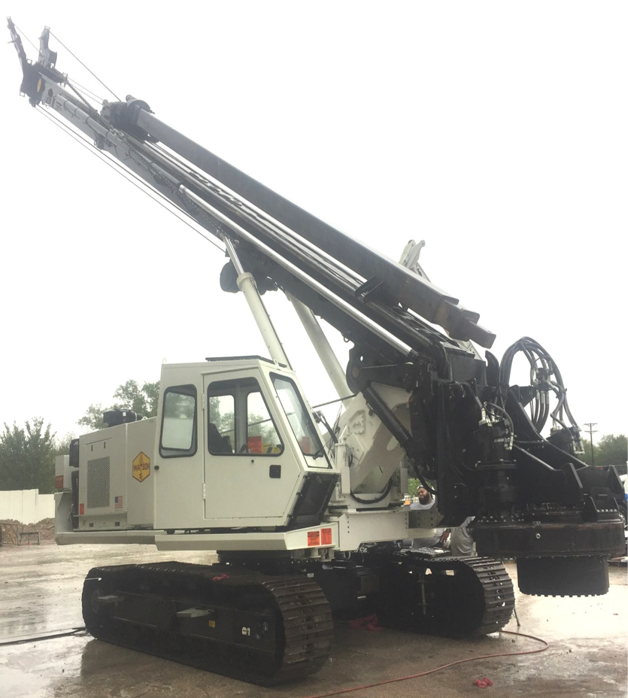
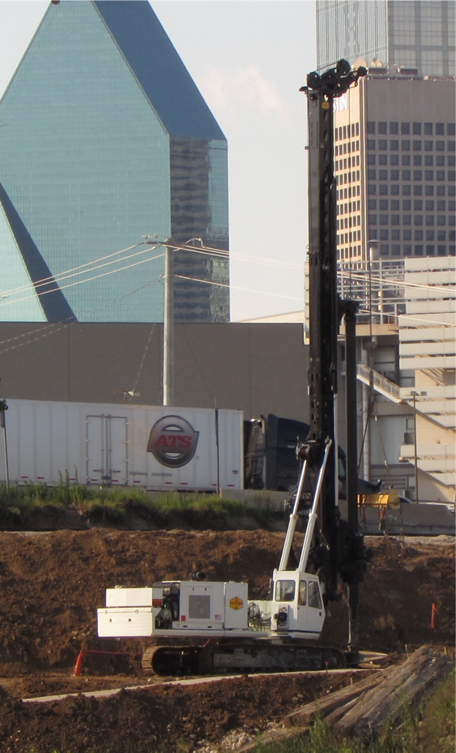

John Deer 6068 - 250hp
138,000 ft-lbs/ Hydraulic Rotary
94 foot drill depth
4-bar kelly (12" outer / 10" / 8" / 6" inner)
40,000 lb. Kelly Winch
50,000 lb. Crowd Force
107,000 lbs. Transport Weight
*Available for RPO

$780,000

