LoDril LM-60 sn21322
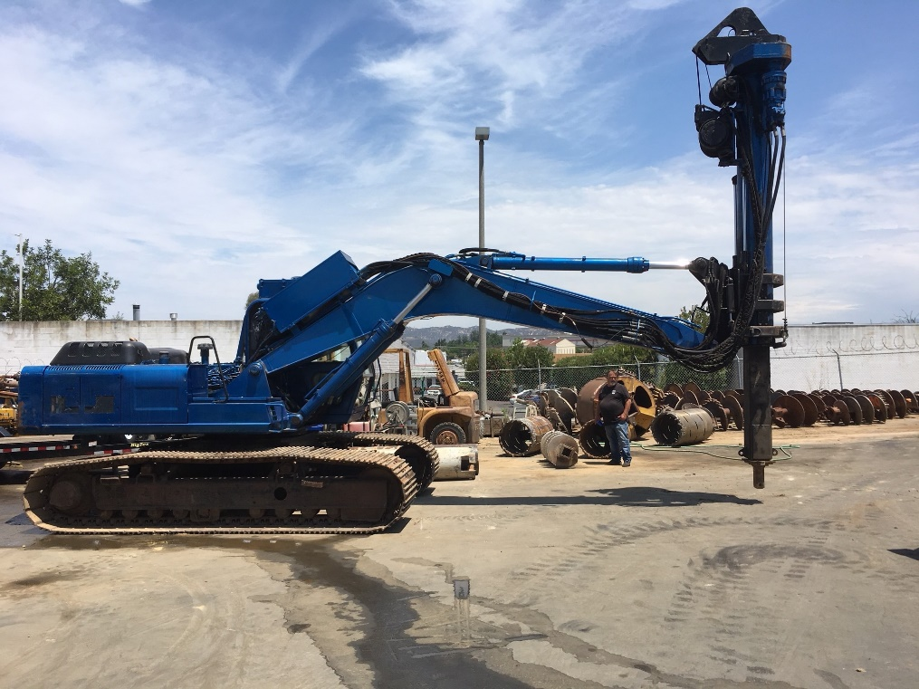
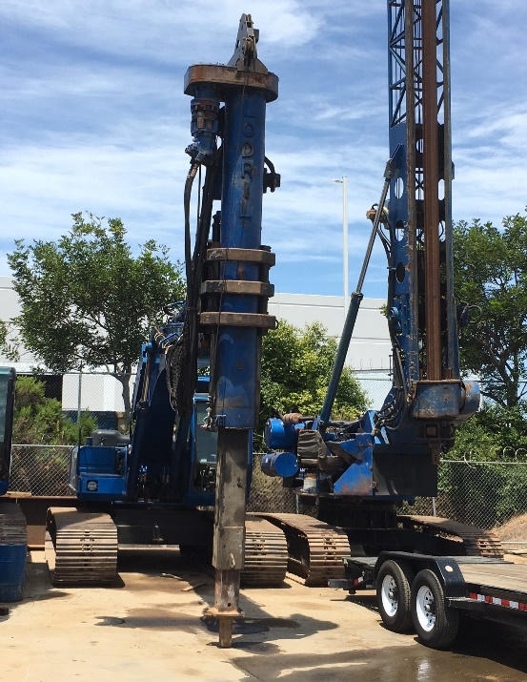
- 60 feet digger
- Newer bars
- 8010 hours
- 4 inch Kelly Stub
- $125,000

