**2012 SR-30 SN 4152**

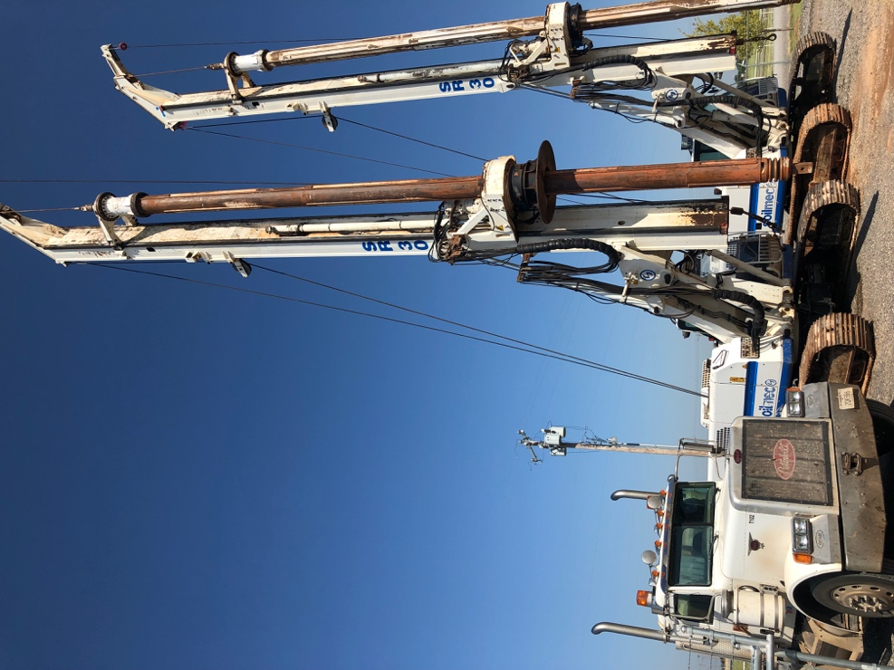

* 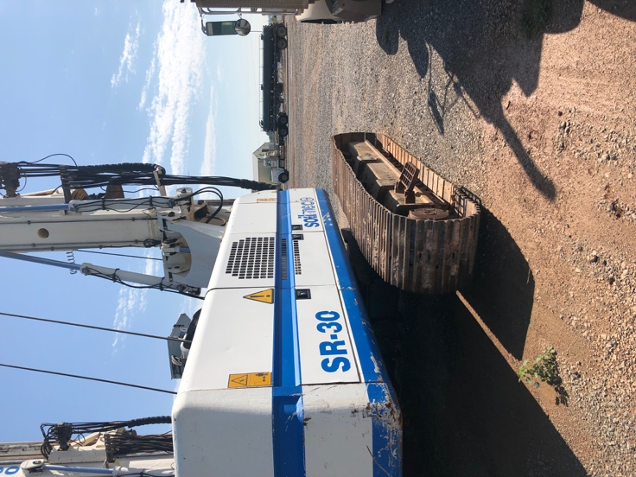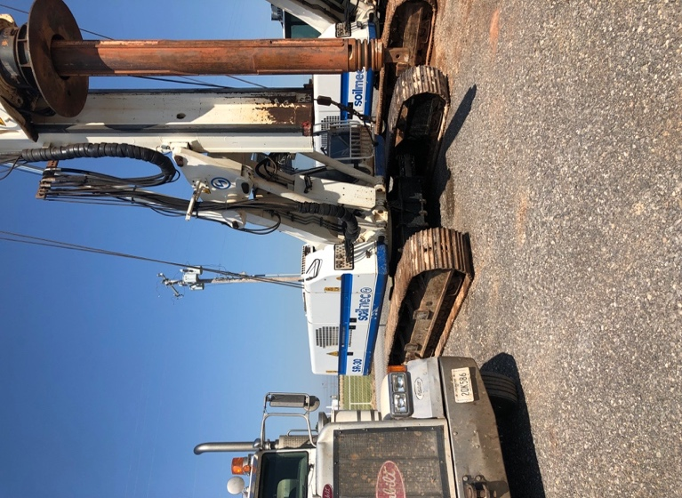**9297 hours**
* **4x12.5m Kelly Bar**
* **$249,000**